
  Eco Audit Report
  Product name
  Wind Blade
  Country of use
  The Whole World
  Product life (years)
  3
Summary:

 |  | 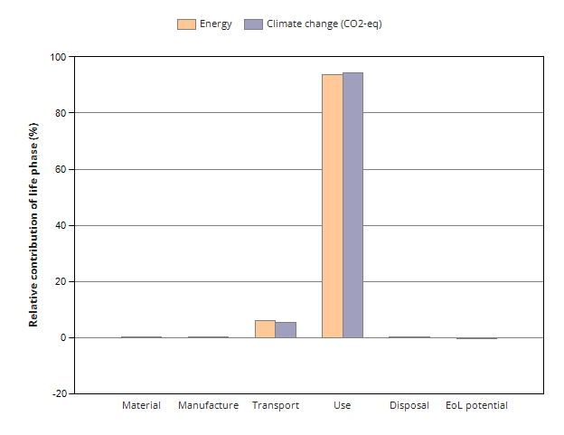
  Energy details
  Climate change (CO2-eq) details
Phase | Energy  (MJ) | Energy  (%) | Climate change (CO2-eq)  (kg) | Climate change (CO2-eq)  (%)
Material | 1.07e+07 | 0.2 | 6.43e+05 | 0.2
Manufacture | 7.32e+05 | 0.0 | 5.48e+04 | 0.0
Transport | 2.8e+08 | 5.9 | 1.85e+07 | 5.5
Use | 4.42e+09 | 93.8 | 3.18e+08 | 94.3
Disposal | 2.49e+04 | 0.0 | 1.75e+03 | 0.0
Total (for first life) | 4.71e+09 | 100 | 3.38e+08 | 100
End of life potential | -3.27e+06 |  | -1.57e+05

Eco Audit Report

Summary

Energy Analysis

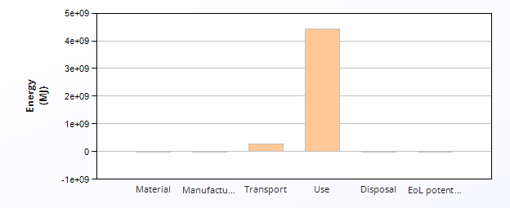
 | Energy (MJ/year)
Equivalent annual environmental burden (averaged over 3 year product life): | 1.57e+09

Detailed breakdown of individual life phases

  Material:
  Summary
Component | Material | Recycled content*  (%) | Part mass  (kg) | Qty. | Total mass  (kg) | Energy  (MJ) | %
Mid Carbon Steel Blade | Medium carbon steel | Virgin (0%) | 23 | 1000 | 2.3e+04 | 7.2e+05 | 6.8
Stainless Steel Blade | Stainless steel | Virgin (0%) | 23 | 1000 | 2.3e+04 | 1.6e+06 | 14.5
Super Ni Blade | Nickel-based superalloys | Virgin (0%) | 23 | 1000 | 2.3e+04 | 7.7e+06 | 72.0
Low key Blade | Low alloy steel | Virgin (0%) | 23 | 1000 | 2.3e+04 | 7.2e+05 | 6.8
Total |  |  |  | 4000 | 9.1e+04 | 1.1e+07 | 100

*Typical: Includes 'recycle fraction in current supply'

***User-defined material

  Manufacture:
  Summary
Component | Process | Amount processed |  | Energy  (MJ) | %
Mid Carbon Steel Blade | Roll forming | 2.3e+04 | kg | 1.2e+05 | 16.1
Stainless Steel Blade | Roll forming | 2.3e+04 | kg | 1.2e+05 | 15.9
Super Ni Blade | Casting | 2.3e+04 | kg | 2.4e+05 | 33.4
Low key Blade | Casting | 2.3e+04 | kg | 2.5e+05 | 34.5
Total |  |  |  | 7.3e+05 | 100

  Transport:
  Summary
Breakdown by transport stage

Stage name | Transport type | Distance  (km) | Energy  (MJ) | %
Ground unit | Truck 16-32t, EURO 6 | 1e+06 | 2.7e+08 | 97.7
Sea unit | Sea, container ship | 5.3e+05 | 6.5e+06 | 2.3
Total |  | 1.6e+06 | 2.8e+08 | 100

Breakdown by components

Component | Mass  (kg) | Energy  (MJ) | %
Mid Carbon Steel Blade | 2.3e+04 | 7e+07 | 25.0
Stainless Steel Blade | 2.3e+04 | 7e+07 | 25.0
Super Ni Blade | 2.3e+04 | 7e+07 | 25.0
Low key Blade | 2.3e+04 | 7e+07 | 25.0
Total | 9.1e+04 | 2.8e+08 | 100

  Use:
  Summary
Mobile mode

Fuel and mobility type | Kerosene - long haul aircraft
Country of use | The Whole World
Product mass  (kg) | 9.1e+04
Distance  (km per day) | 1e+04
Usage (days per year) | 2.5e+02
Product life (years) | 3

  Relative contribution of static and mobile modes
Mode | Energy  (MJ) | %
Static | 0
Mobile | 4.4e+09 | 100.0
Total | 4.4e+09 | 100

Breakdown of mobile mode by components

Component | Energy  (MJ) | %
Mid Carbon Steel Blade | 1.1e+09 | 25.0
Stainless Steel Blade | 1.1e+09 | 25.0
Super Ni Blade | 1.1e+09 | 25.0
Low key Blade | 1.1e+09 | 25.0
Total | 4.4e+09 | 100

  Disposal:
  Summary
Component | End of life option | Energy  (MJ) | %
Mid Carbon Steel Blade | Landfill | 4.5e+03 | 18.2
Stainless Steel Blade | Landfill | 4.5e+03 | 18.2
Super Ni Blade | Downcycle | 1.1e+04 | 45.5
Low key Blade | Landfill | 4.5e+03 | 18.2
Total |  | 2.5e+04 | 100

EoL potential:

Component | End of life option | Energy  (MJ) | %
Mid Carbon Steel Blade | Landfill | 0 | 0.0
Stainless Steel Blade | Landfill | 0 | 0.0
Super Ni Blade | Downcycle | -3.3e+06 | 100.0
Low key Blade | Landfill | 0 | 0.0
Total |  | -3.3e+06 | 100

  Notes:
  Summary

Eco Audit Report

Summary

Climate Change (CO2-eq) Analysis

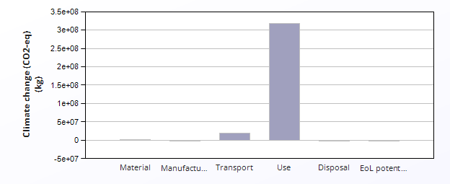
 | CO2 (kg/year)
Equivalent annual environmental burden (averaged over 3 year product life): | 1.13e+08

Detailed breakdown of individual life phases

  Material:
  Summary
Component | Material | Recycled content*  (%) | Part mass  (kg) | Qty. | Total mass  (kg) | Climate change (CO2-eq)  (kg) | %
Mid Carbon Steel Blade | Medium carbon steel | Virgin (0%) | 23 | 1000 | 2.3e+04 | 5.3e+04 | 8.2
Stainless Steel Blade | Stainless steel | Virgin (0%) | 23 | 1000 | 2.3e+04 | 1.3e+05 | 20.7
Super Ni Blade | Nickel-based superalloys | Virgin (0%) | 23 | 1000 | 2.3e+04 | 4e+05 | 62.9
Low key Blade | Low alloy steel | Virgin (0%) | 23 | 1000 | 2.3e+04 | 5.3e+04 | 8.2
Total |  |  |  | 4000 | 9.1e+04 | 6.4e+05 | 100

*Typical: Includes 'recycle fraction in current supply'

***User-defined material

  Manufacture:
  Summary
Component | Process | Amount processed |  | Climate change (CO2-eq)  (kg) | %
Mid Carbon Steel Blade | Roll forming | 2.3e+04 | kg | 8.9e+03 | 16.2
Stainless Steel Blade | Roll forming | 2.3e+04 | kg | 8.7e+03 | 15.9
Super Ni Blade | Casting | 2.3e+04 | kg | 1.8e+04 | 33.4
Low key Blade | Casting | 2.3e+04 | kg | 1.9e+04 | 34.5
Total |  |  |  | 5.5e+04 | 100

  Transport:
  Summary
Breakdown by transport stage

Stage name | Transport type | Distance  (km) | Climate change (CO2-eq)  (kg) | %
Ground unit | Truck 16-32t, EURO 6 | 1e+06 | 1.8e+07 | 97.3
Sea unit | Sea, container ship | 5.3e+05 | 4.9e+05 | 2.7
Total |  | 1.6e+06 | 1.9e+07 | 100

Breakdown by components

Component | Mass  (kg) | Climate change (CO2-eq)  (kg) | %
Mid Carbon Steel Blade | 2.3e+04 | 4.6e+06 | 25.0
Stainless Steel Blade | 2.3e+04 | 4.6e+06 | 25.0
Super Ni Blade | 2.3e+04 | 4.6e+06 | 25.0
Low key Blade | 2.3e+04 | 4.6e+06 | 25.0
Total | 9.1e+04 | 1.9e+07 | 100

  Use:
  Summary
Mobile mode

Fuel and mobility type | Kerosene - long haul aircraft
Country of use | The Whole World
Product mass  (kg) | 9.1e+04
Distance  (km per day) | 1e+04
Usage (days per year) | 2.5e+02
Product life (years) | 3

  Relative contribution of static and mobile modes
Mode | Climate change (CO2-eq)  (kg) | %
Static | 0
Mobile | 3.2e+08 | 100.0
Total | 3.2e+08 | 100

Breakdown of mobile mode by components

Component | Climate change (CO2-eq)  (kg) | %
Mid Carbon Steel Blade | 8e+07 | 25.0
Stainless Steel Blade | 8e+07 | 25.0
Super Ni Blade | 8e+07 | 25.0
Low key Blade | 8e+07 | 25.0
Total | 3.2e+08 | 100

  Disposal:
  Summary
Component | End of life option | Climate change (CO2-eq)  (kg) | %
Mid Carbon Steel Blade | Landfill | 3.2e+02 | 18.2
Stainless Steel Blade | Landfill | 3.2e+02 | 18.2
Super Ni Blade | Downcycle | 7.9e+02 | 45.5
Low key Blade | Landfill | 3.2e+02 | 18.2
Total |  | 1.7e+03 | 100

EoL potential:

Component | End of life option | Climate change (CO2-eq)  (kg) | %
Mid Carbon Steel Blade | Landfill | 0 | 0.0
Stainless Steel Blade | Landfill | 0 | 0.0
Super Ni Blade | Downcycle | -1.6e+05 | 100.0
Low key Blade | Landfill | 0 | 0.0
Total |  | -1.6e+05 | 100

  Notes:
  Summary

